Rotate a Linked List
Problem Statement: Given the head of a linked list, rotate the list to the right by k places.
Examples:
Example 1:
Input:
head = [1,2,3,4,5]
k = 2
Output:
head = [4,5,1,2,3]
Explanation:
We have to rotate the list to the right twice.

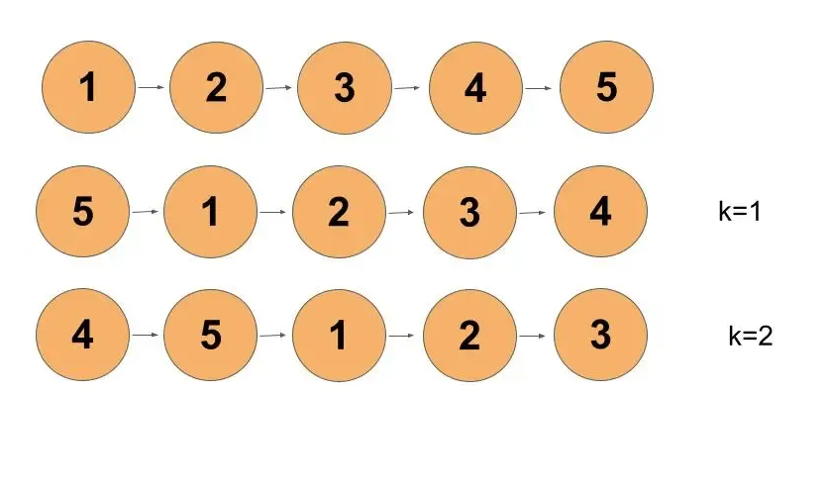

Solution: Optimal Solution
Approach:
Let’s take an example.
head = [1,2,3,4,5] k = 2000000000
If we see a brute force approach, it will take O(5*2000000000) which is not a good time complexity when we can optimize it.
We can see that for every k which is multiple of the length of the list, we get back the original list. Try to operate brute force on any linked list for k as a multiple of the length of the list.
This gives us a hint that for k greater than the length of the list, we have to rotate the list for k%length of the list. This reduces our time complexity.
Steps to the algorithm:-
- Calculate the length of the list.
- Connect the last node to the first node, converting it to a circular linked list.
- Iterate to cut the link of the last node and start a node of k%length of the list rotated list.
Dry Run:
Let’s calculate the length of the list by iterating on it until it reaches null and increasing the count. Once the length is calculated we will connect the last node to the first node.
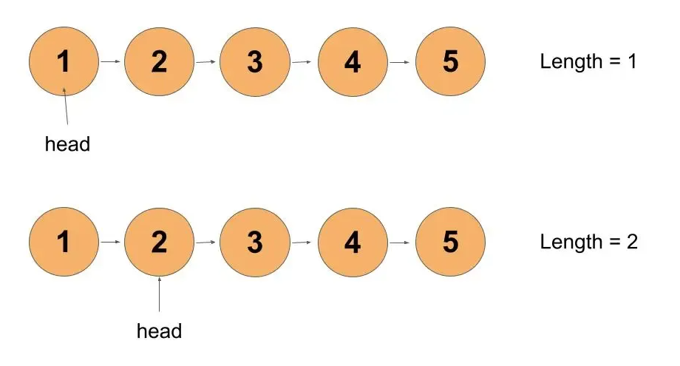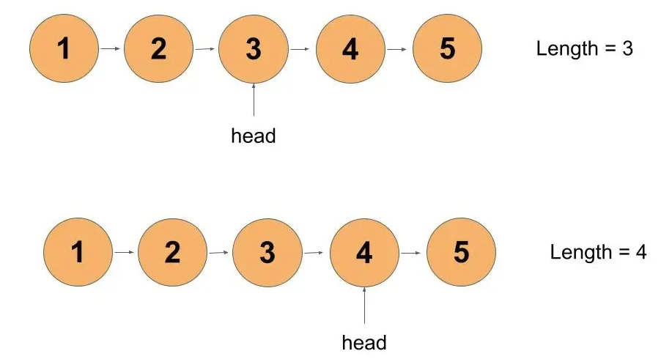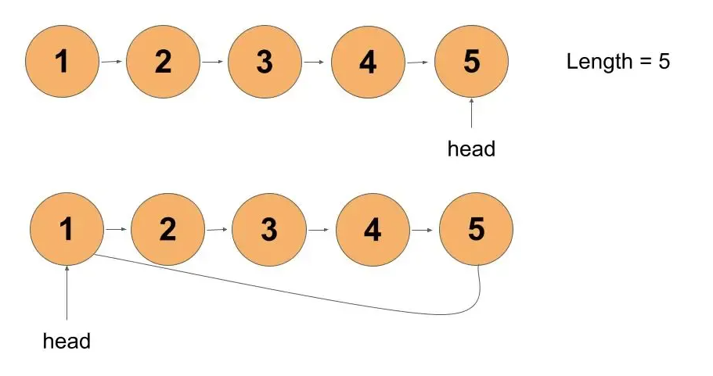
Now, the length of the list is 5 and k is 2. k is less than the length of the given list. So, we will have the head of the rotating list at the kth element from the end remove the link from the length-k node from its next node and make it NULL.
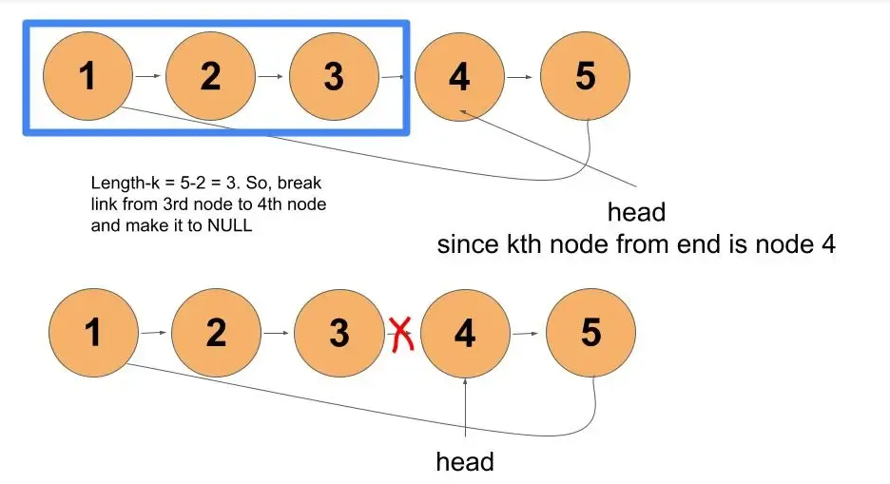
Thus, we received our desired output.
Code:
import java.util.*;
class Node {
int num;
Node next;
Node(int a) {
num = a;
next = null;
}
}
class TUF{
//utility function to insert node at the end of the list
static Node insertNode(Node head,int val) {
Node newNode = new Node(val);
if(head == null) {
head = newNode;
return head;
}
Node temp = head;
while(temp.next != null) temp = temp.next;

temp.next = newNode;
return head;
}
//utility function to rotate list by k times
static Node rotateRight(Node head,int k) {
if(head == null||head.next == null||k == 0) return head;
//calculating length
Node temp = head;
int length = 1;
while(temp.next != null) {
++length;
temp = temp.next;
}
//link last node to first node
temp.next = head;
k = k%length; //when k is more than length of list
int end = length-k; //to get end of the list
while(end--!=0) temp = temp.next;
//breaking last node link and pointing to NULL
head = temp.next;
temp.next = null;

return head;
}
}
Time Complexity: O(length of list) + O(length of list - (length of list%k))
Reason: O(length of the list) for calculating the length of the list. O(length of the list - (length of list%k)) for breaking link.
Space Complexity: O(1)

